Two Schools of Congregational Development
Monday, March 26, 2018

On “A Means of Grace, Hope of Glory”
www.congregationaldevelopment.com/means-of-grace-hope-of-glory/2018/3/26/two-schools-of-congregational-development.html

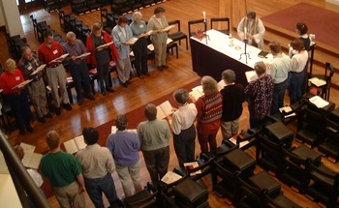

There's an excellent article appearing in the April 8 issue of the Living Church -- "Two Schools of Congregational Development" by Kirk Petersen. It touches on how two congregational development programs were impacted by my divorce in 2008. But in the main its focus is on describing the College for Congregational Development and the Diocesan CDI programs. I hope you'll take a look at the write up on two proven programs.

Petersen notes "Both organizations draw rave reviews from participants." He goes on to note the many similarities between the programs, e.g., two years, multiple dioceses, lay and clergy teams from parishes, the use of organization development, and each has involved two bishops in the training. Both have a commitment to diocesan based programs. He also wrote about how the people in each program are not very familiar with the other.

My impression is that the Diocesan CDI program may place more emphasis on pastoral and ascetical theology and practice in its work. But that's just an impression. I'd love to get together with leaders from both programs. We could share what each is doing and take a look at how both might improve. Michelle Heyne and I could offer a few ideas from our work in Shaping the Parish (see three ideas toward the bottom of this page).

There was one error in the story that a former CDI trainer brought to my attention. In the article Kirk Petersen writes:

“Consciously or otherwise, DCDI has also borrowed a page from CCD play book by evolving into a diocesan based organization. It previously had been a national program, first at seminaries and then as a standalone organization. The “Diocesan”was added to convocation development Institute in 2011 to create DCDI.”

Actually it's the reverse. There were 13 diocesan CDIs years before the College was formed -- CDIs in the dioceses of Atlanta, Connecticut, Milwaukee, Newark, North Carolina, Northern Indiana, Rochester, Southwest Florida, Southwest Virginia, Virginia, Washington, Western New York, and Western Massachusetts. Around the time CCD was being formed there was also a CDI in Utah. The Diocesan CDIs have been in Georgia, Milwaukee, Long Island, Northern Indiana, Western Michigan, Eastern Michican, and Colorado.

We might increase our understanding of the similarities and differences of the programs by looking at their reading lists -- DCDI (Georgia) CCD Shaping the Parish
We'll add the reading list for Associates of the Order of the Ascension.

This is an addition - Apparently there were people associate with CCD who were unhappy with the Living Church article. Melissa Skelton, founder of CCD, wrote a letter to the editor. While there's much in the letter that Michelle Heyne and Bob Gallagher see differently their emphasis moves in another direction.
We hope the current leadership of the two programs would agree to set aside, place on the shelf, all the old arguments about who did what, which program founder has the superior training and experience, and which program is the best. Maybe it's a time in which the battles might be set aside and the parties spend time with one another focused on their love of God and of the church. More information on the article and dispute.

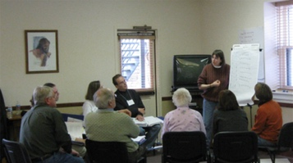

More background
If you are interested in more background on the history of parish development in the Episcopal Church, here are two sources -
Understanding from Within
Michelle Heyne and I wrote an article for the Organization Development Practitioner in the Winter 2015 edition. Here's a link to that edition. There's also a posting on this site that adds to the OD Practitioner article.
The article was written for members of the OD Network, the largest professional association of organization development practitioners. That's a largely secular audience and the piece is written in a manner that reflects that.
We also wrote a posting for those OD Practitioners who wanted more information on the models mentioned in the article. It's also a resource for parish development practitioners in the church seeking resources. Here's a link to that article.
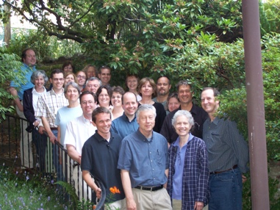

That piece notes that people doing parish development need to "understand from within" if their work is to be effective:
1. We are more likely to "understand" and be received if we are proficient Christians grounded in this Anglican way of being a Christian.
2. Taking an appreciative, curious, open stance toward the parish and the tradition will also help. If we had to chose between a competent secular OD consultant with such appreciation and an Episcopalian taking a dismissive stance toward parishes, with a list of "three things all parishes must do," we'd select the non-religious consultant.
3. Our understand will be richer and deeper if we are familiar with systems oriented pastoral/ascetical theology models of the parish church. Such models are teased out of the actual experience of the parish church in relationship with the church's self understanding of its nature, mission, and inner life.

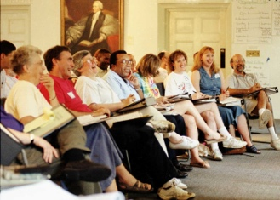

The History of Parish Development in the Episcopal Church
It provides an overview of the field, the history, and a reflection on the current state of the field (a bit dated). It explains three streams to the field: pastoral and ascetical theology, organization development, and a blending of the two.
There's also a discussion of six ways in which parishes have done parish development: best practices, limited competency development, longer and more intensive leadership training programs, and so on.
As you'd expect there's a good bit on the development and evolution of the Church Development Institute.
We end by offering three suggestions that we think might improve the existing DCDI and CCD programs:
We are offering a few suggestions to DCDI and CCD based on what was learned in Shaping the Parish:
1. Provide developmental interventions (projects) for participants to use that are designed to be truly developmental. Support that with coaching from experienced trainers. Comment - we continue to hear about projects that are designed by participants in the two programs. Most are not really developmental. Of course participants can still learn about the process of change in a parish as well as about their own emotional and spiritual life as they engage the work. Participant skills can be better increased if they are provided with a few well designed developmental initiatives to carry out in the first year of the program. That pattern might be continued or they might then be invited to design their own projects.
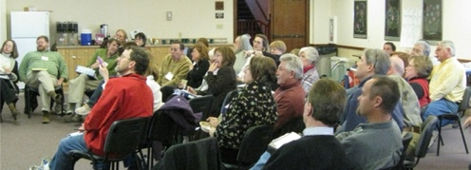

2. Begin with a weekend T-group and the use of several instruments (MBTI, FIRO B, and TKI). Information on T-groups -- Crosby Gallagher. Our Shaping the Parish experience suggest that doing these activities at the front end of a program creates a more open learning environment that persists, establishes a norm of useful and skilled feedback, and sharpens the emotional intelligence of most participants. A difficulty with this is that it means that the training staff need to have a much higher level of training competence.
3. We invite the leaders of DCDI and CCD to borrow from what we learned in Shaping the Parish.
"The History of Parish Development in the Episcopal Church" -- Here's the link.
rag+
The pictures
CDI-Washington (around 2001) - a diocesan program
CDI-Colorado (around 2008) - a diocesan program
CDI-Seattle (2007) - a national program
CDI-General Seminary (early 1990's?) - a national program
CDI Colorado (2008) - a diocesan program

